**PVC PIPE BURSTING**

Apparatus used:

PVC Pipe bursting set-up.

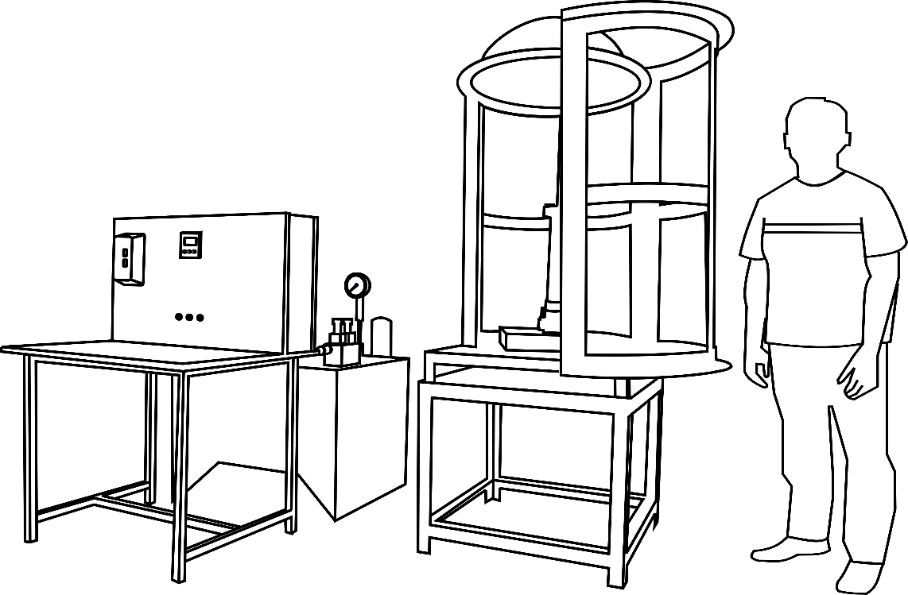

**STEP:➊** The pipe to be tested must have nearly uniform ends i.e., both ends trimmed to ensure parallel faces.

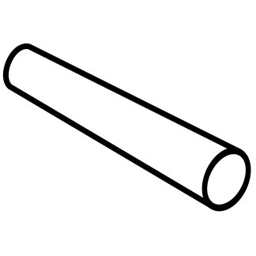

**STEP:❷** The minimum length to mean diameter ratio of pipe must be 3, so that effect of end flange clamping does not affect the bursting pressure.

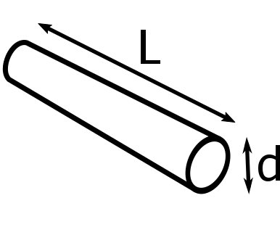

**STEP:➌** Insert the bottom flange in the pipe and then wedge ring one end and then mount the top flange in the pipe and clamp it with the help of bolts provided. This causes gripping of the flange to the pipe.

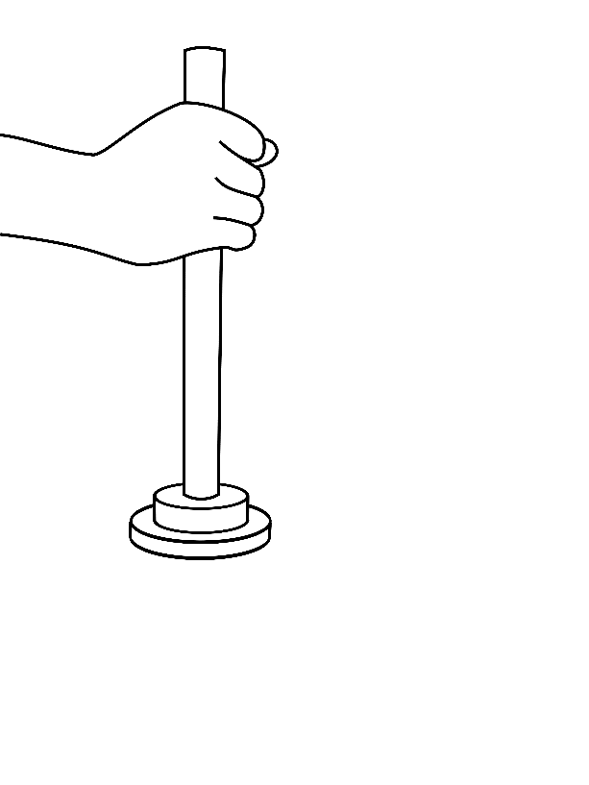

**STEP:** **➍** Repeat the previous step for other end of the pipe.

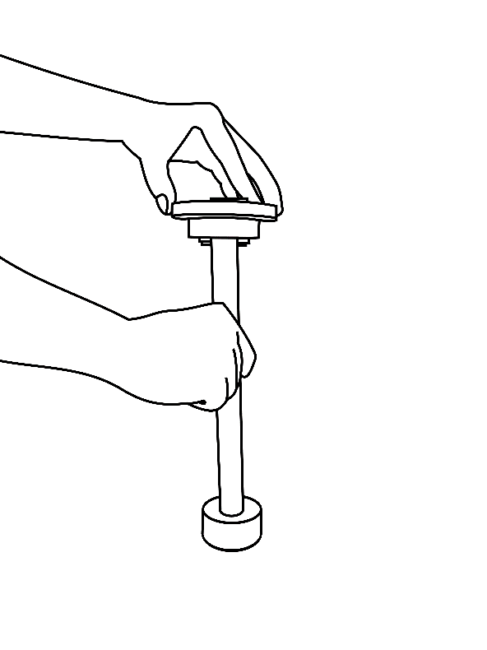

**STEP:** **➎** Now connect the pipe mounted with flanges on the test platform. Ensure that the top vent bolt is loose.

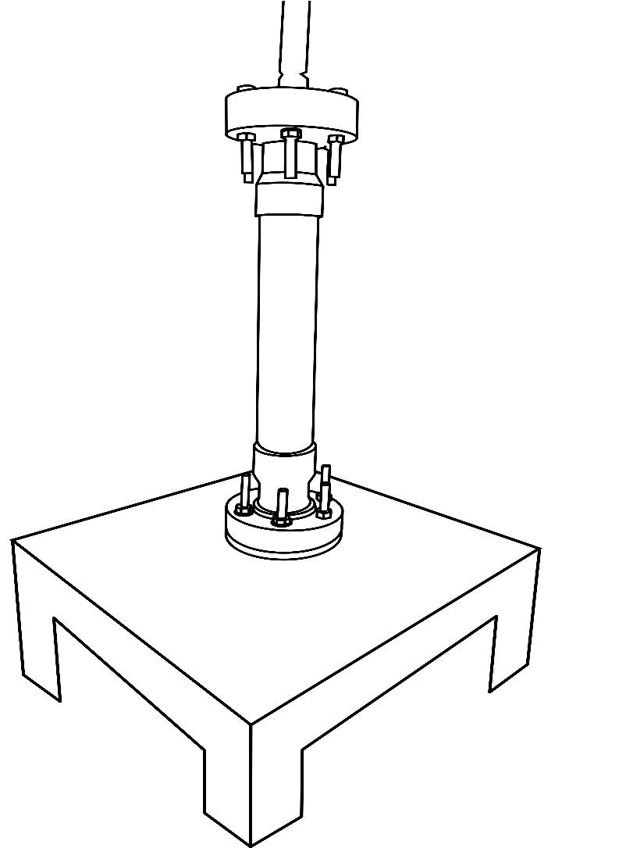

**STEP:** **➏** Start the power pack to pump in oil and let the air to escape from the top vent bolt provided. Allow some continuous leak out of oil from top vent bolt which ensures proper bleeding and then tighten the top bolt for no further leak.

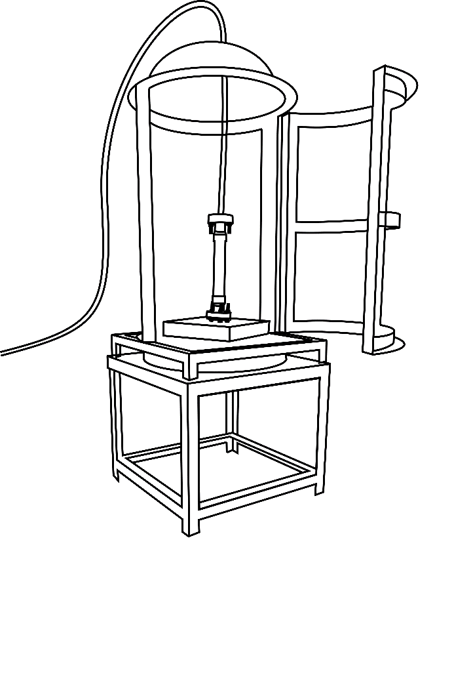

**STEP:➐** The pump is switched off after pre-filling and air bleed out.

**STEP:➑** Now start the hand pump and slowly build the pressure. .As the pressure nears to the theoretical pressure, slow down the pumping rate and wait for appearance of longitudinal cracks and consequent sudden drop in pressure.

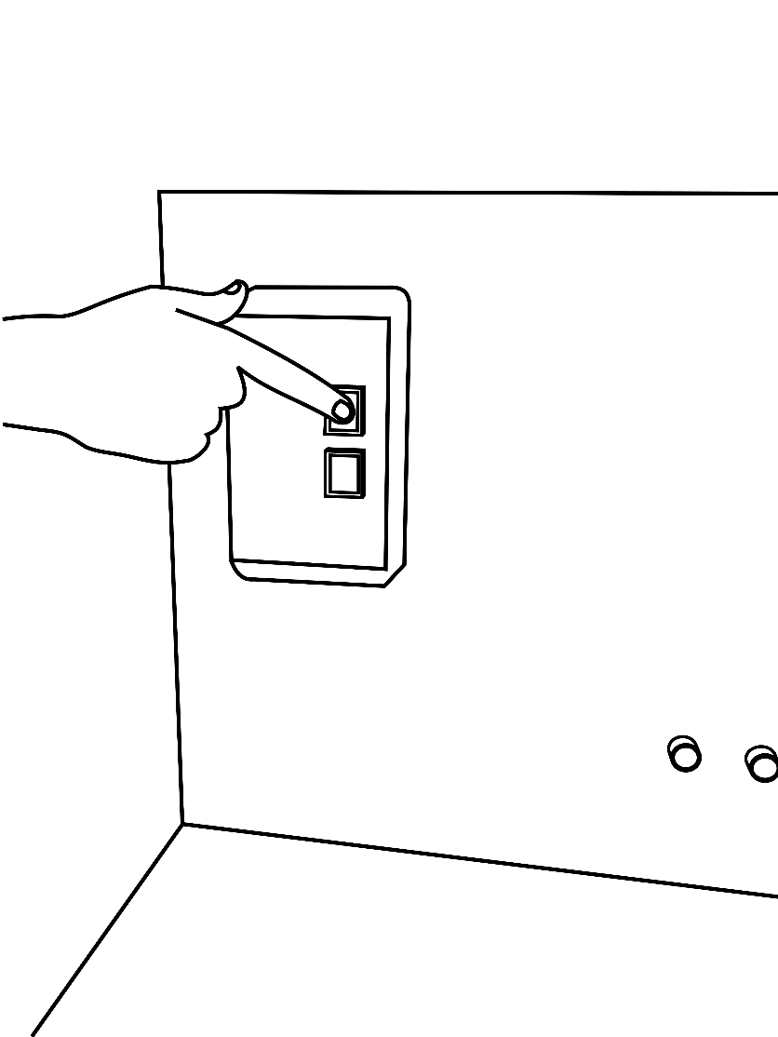

**STEP:**❾ The maximum pressure reached is recorded in the pressure peak hold indicator. The pipe bursting pressure is calculated based on the Von-Mises stress.

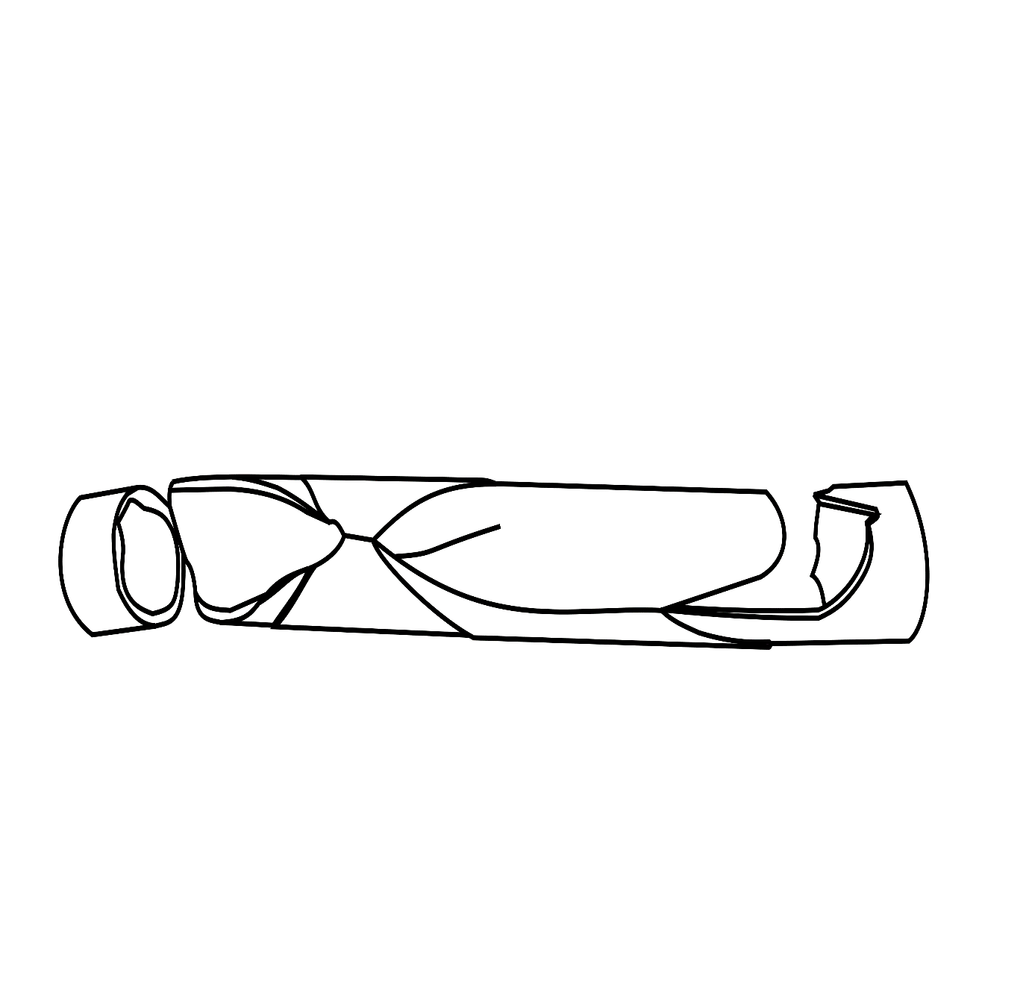

Outer diameter of pipe = _____mm

Thickness of pipe = _____mm

Outer radius of pipe (r2) = _____mm

Inner radius of pipe (r1) = _____mm

Ultimate Tensile strength of pipe (UTS) = _____mm

r1/t =



=_____kgf/mm2